Assignment-3.3
Karunya
2303A52364
b-32
Task 1: AI-Generated Logic for Reading Consumer Details
Scenario
An electricity billing system must collect accurate consumer data.
Task Description
Use an AI tool (GitHub Copilot / Gemini) to generate a Python program that:
- Reads:
  - Previous Units (PU)
  - Current Units (CU)
  - Type of Customer
- Calculates units consumed
- Implements logic directly in the main program (no functions)
Expected Output
- Correct input reading
- Units consumed calculation
- Screenshot showing AI-generated code
- Sample input and output
Prompt:
Code:
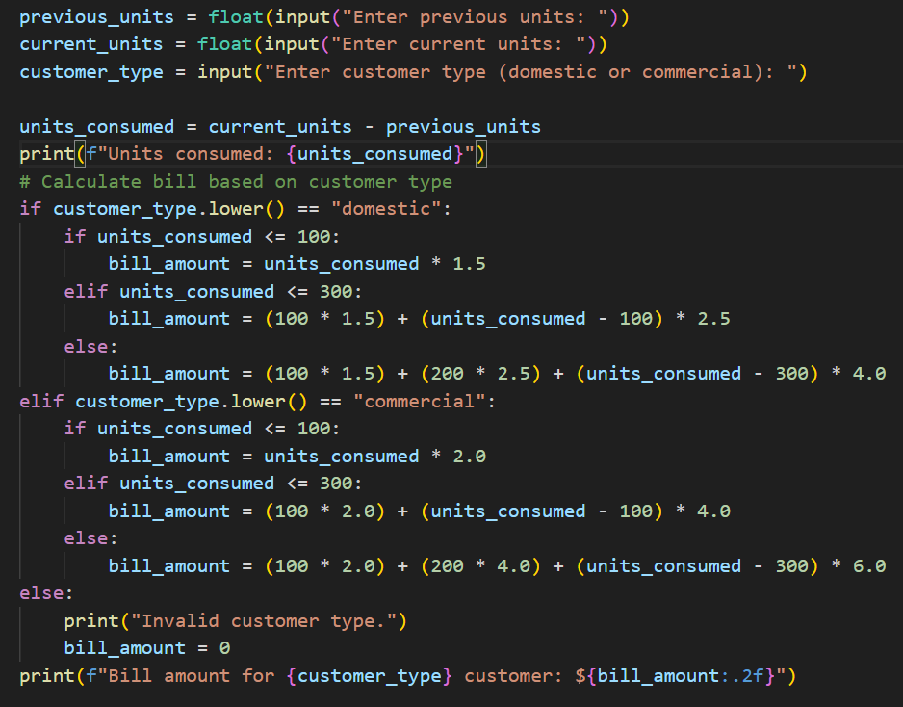
output:
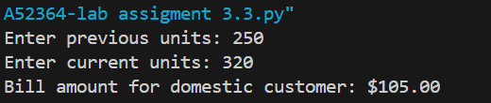
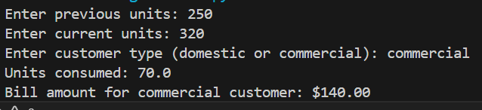
suggestion:
The program accepts Previous Units, Current Units, and the Type of Customer as input.
It calculates the total units consumed by subtracting previous units from current units.
All the logic is implemented directly in the main program without using functions.
The output clearly displays the units consumed along with sample input and output results.

Task 2: Energy Charges Calculation Based on Units Consumed
Scenario
Energy charges depend on the number of units consumed and customer type.
Task Description
Review the AI-generated code from Task 1 and extend it to:
- Calculate Energy Charges (EC)
- Use conditional statements based on:
  - Domestic
  - Commercial
  - Industrial consumers
- Improve readability using AI prompts such as:
  - “Simplify energy charge calculation logic”
  - “Optimize conditional statements”
Expected Output
- Correct EC calculation
- Clear conditional logic
- Original and improved versions (optional)
- Sample execution results

Prompt:
code:
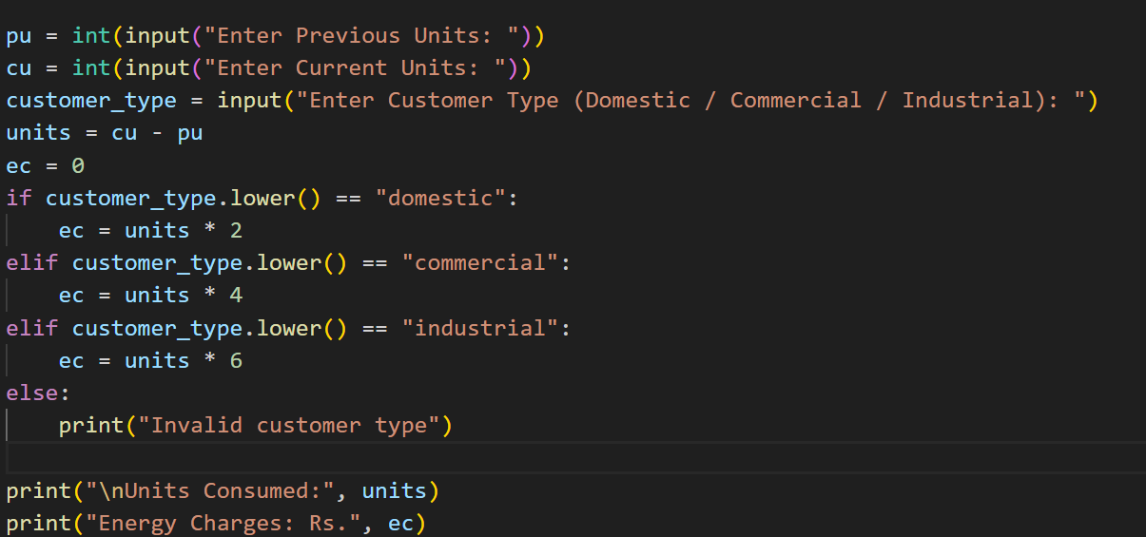
Output:
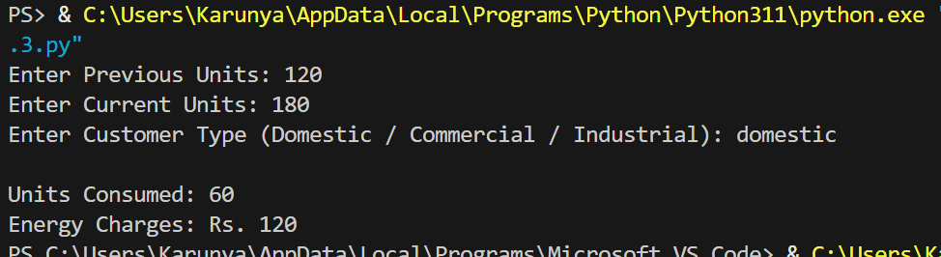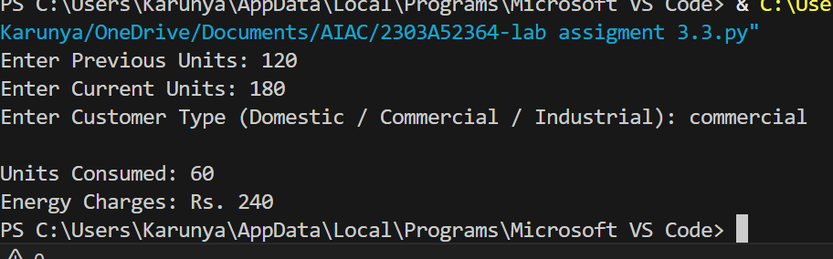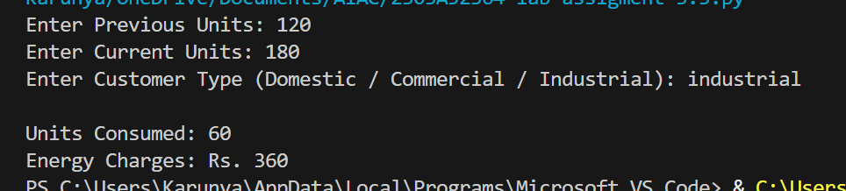
Suggestion:
This task extends the AI-generated program from Task 1 to calculate energy charges based on units consumed and customer type. Conditional statements are used to apply different tariff rates for domestic, commercial, and industrial consumers. AI prompts are applied to simplify the energy charge calculation logic and optimize the conditional structure for better readability. The improved code clearly shows how charges are calculated for each customer type. Sample inputs and outputs are included to demonstrate correct energy charge calculation.

Task 3: Modular Design Using AI Assistance (Using Functions)
Scenario
Billing logic must be reusable for multiple consumers.
Task Description
Use AI assistance to generate a Python program that:
- Uses user-defined functions to:
  - Calculate Energy Charges
  - Calculate Fixed Charges
- Returns calculated values
- Includes meaningful comments
Expected Output
- Function-based Python program
- Correct EC and FC values
- Screenshots of AI-assisted function generation
- Test cases with outputs

Prompt:

Code:
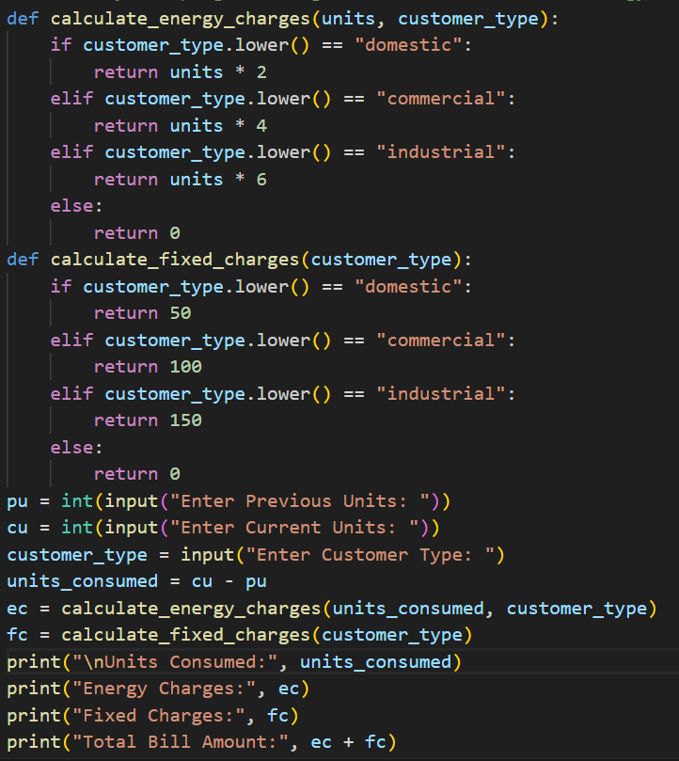
Output:
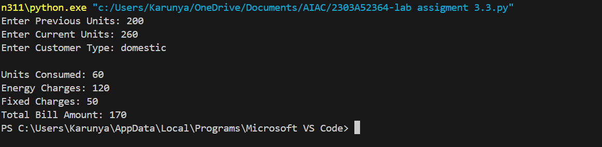
Suggestion:
This task uses AI assistance to design a modular Python program for electricity billing. User-defined functions are created to calculate energy charges and fixed charges separately. Each function returns the calculated value, making the code reusable and organized. Meaningful comments are added to explain the logic clearly. Test cases with sample outputs are included to verify correct calculations.

Task 4: Calculation of Additional Charges
Scenario
Electricity bills include multiple additional charges.
Task Description
Extend the program to calculate:
- FC – Fixed Charges
- CC – Customer Charges
- ED – Electricity Duty (percentage of EC)
Use AI prompts like:
- “Add electricity duty calculation”
- “Improve billing accuracy”
Expected Output
- Individual charge values printed
- Correct duty calculation
- Well-structured output
- Verified intermediate results
Prompt:
Code:
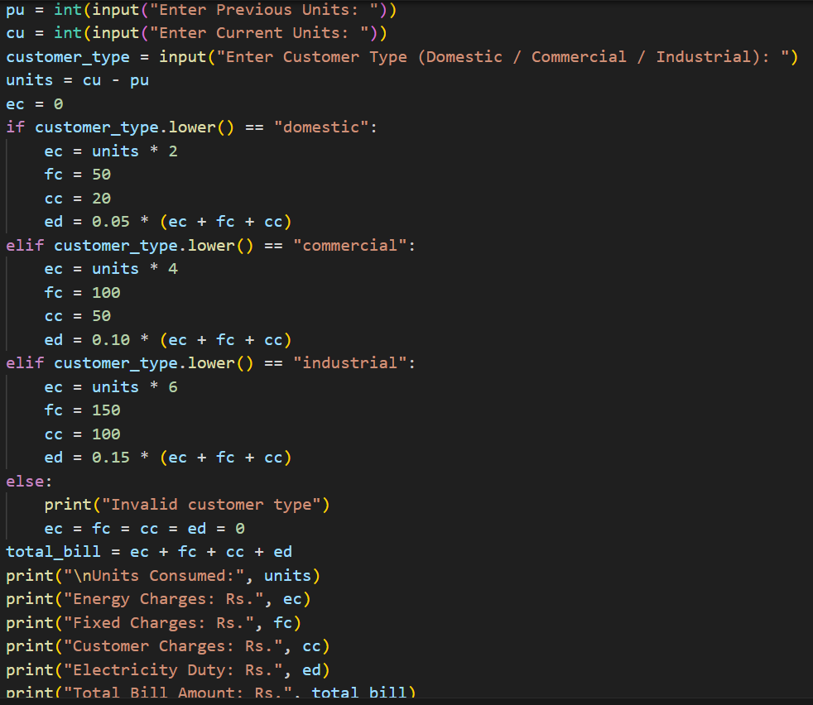
Output:
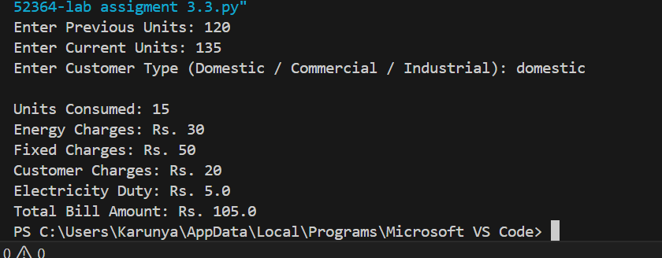
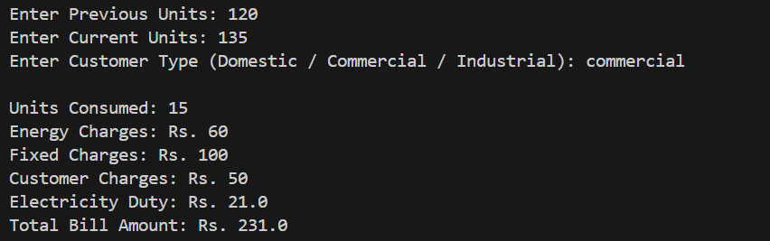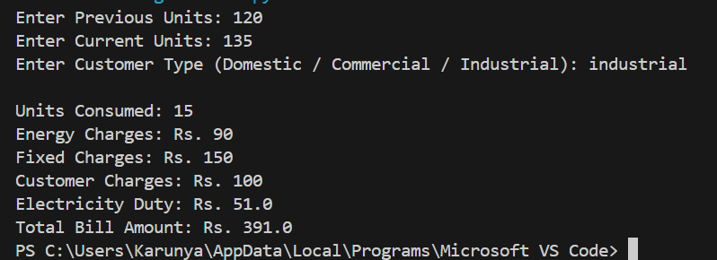
Suggestion:
This task extends the billing program to include additional charges such as fixed charges, customer charges, and electricity duty. AI prompts are used to add electricity duty calculation as a percentage of energy charges and to improve overall billing accuracy. The program prints each charge separately for better clarity. The output is well structured and shows verified intermediate calculation results.
Task 5: Final Bill Generation and Output Analysis
Scenario
The final electricity bill must present all values clearly.
Task Description
Develop the final Python application to:
- Calculate total bill:
- Total Bill = EC + FC + CC + ED
- Display:
  - Energy Charges (EC)
  - Fixed Charges (FC)
  - Customer Charges (CC)
  - Electricity Duty (ED)
  - Total Bill Amount
- Analyze the program based on:
  - Accuracy
  - Readability
  - Real-world applicability
Expected Output
- Complete electricity bill output
- Neatly formatted display
- Sample input/output

Prompt:
Code:
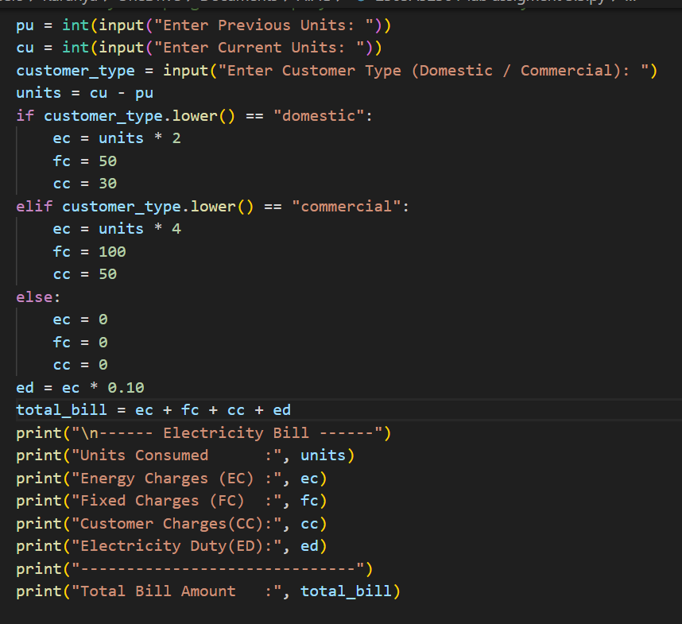
Output:
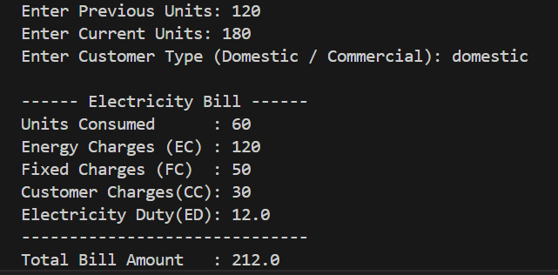

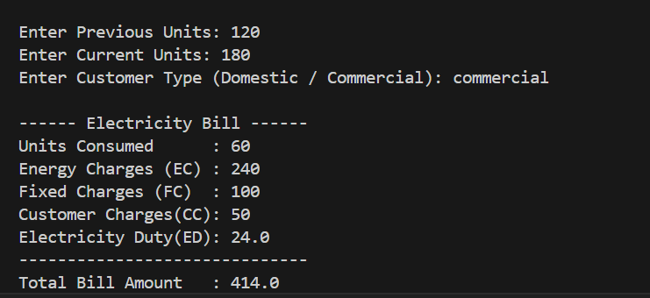
Suggestion
This program gives accurate bill calculation based on units used and customer type. The code is easy to read because of simple variables and clear output format. It can be used in real life for basic electricity billing systems.

